**Project Report**

**Title:** IST network

**Submitted by:**

Name: Huzaifa Tariq

Reg NO: 230201039

Name: Ali Aoun

**Submitted to:**

Mam Mahnoor

Lecturer

Department of Computer Science

Institute of Space Technology

**Submission Date:** 15/01/2025

# Preface:

Designing a full-fledged network for an organization with multiple subnets is useful and real-life problem in networking course. I applied all the basics I learnt from my classes. I studied on this project from online also and got hints from google and YouTube as well, therefore I applied those ideas for better designing. This project reflects the overall leaning from the course cse405. I had experienced a lot and that will undoubtedly help me in my future career. The purpose of this project was to create a network complex. This project also provided me the knowledge about how to practically implement a sophisticated network design.

# Objective:

There is total 7 campuses of a university named UNIVERSITY OF SCHOLARS. I had to design a full-fledged network for the university with multiple subnets of its campuses. I created a webpage for University of Scholars. In the network field, it can be accessed through the address <http://www.scholars.edu>. There I used total 7routers to for the 7 campuses of the university. That reflected the complex network along with sub-nets inside each campus.

# Implementation Details:

The network design was implemented in Cisco Packet Tracer. To incorporate all the 7 different campuses as well as connecting it to a separate Server Room for DNS, DHCP and WEB server in the campus-5. A dynamic network of routers was used. Every network was designed in such a way that all are using subnet for future extend.

# Physical Diagram:

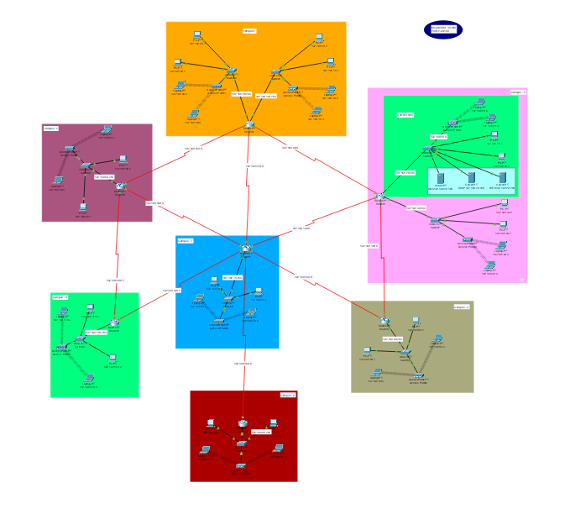

The Network elements used in the project were:

1. Connectors -Straight Through Cable
2. Total 7 Routers
3. Switches for each router.
4. Total 3 Servers (DNS, DHCP and WEB)
5. 4-8 PCs for each campus
6. Wireless Access points to connect laptops.
7. Used DNS for auto ip addressing.
8. Used DHCP for dynamically provide IP addresses to all the hosts present in the 7 campuses.
9. Used WEB services including web page creating.
10. There is total 9 wireless networks secured by WEP

**Webserver:**

The Web Server was used to provide the webpage of University of Scholars which can be accessed through any of the hosts in any network.

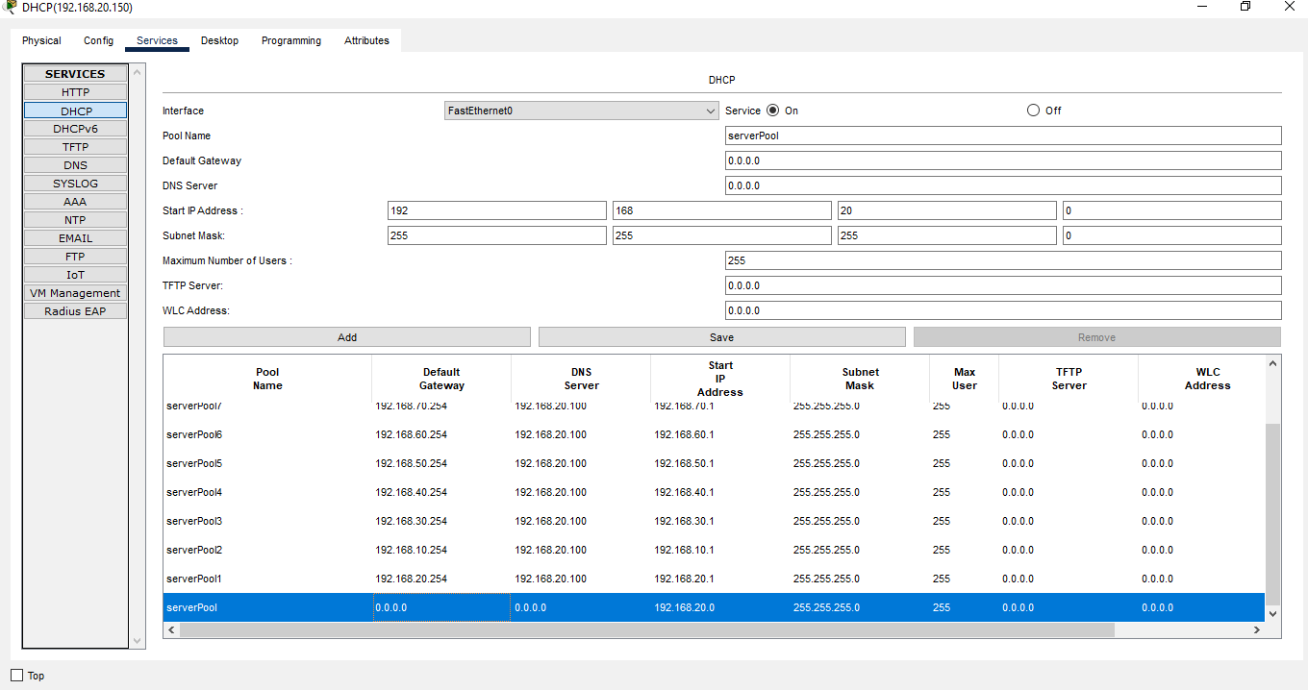

The Web Server was used to provide the webpage of University of Scholars which can be accessed through any of the hosts in any network. Here the given webserver URL for the [www.scholars.edu](http://www.scholars.edu). to find the university. The DNS server was used so that all the hosts can access the webpage in the Web Server through the required web address instead of the IP address of the Web Server.

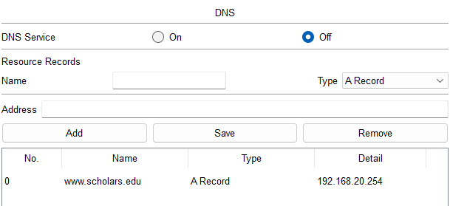

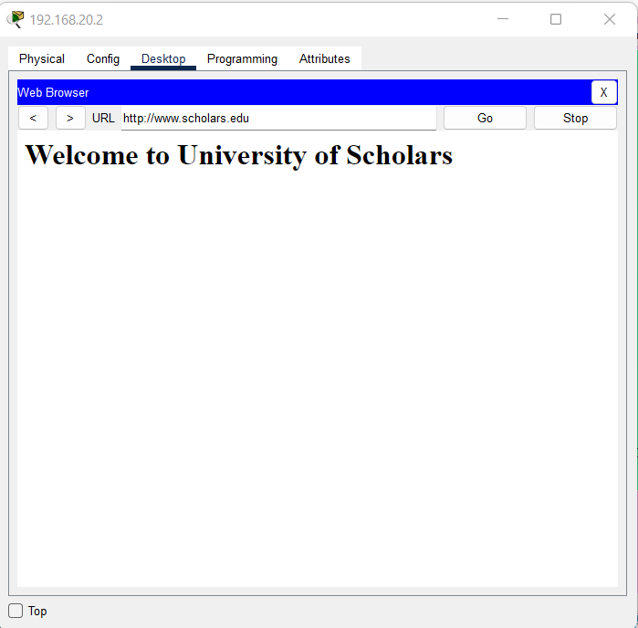

**Wireless connection:**

The wireless connections were possible through wireless Access Points present in each network. The Access Points were secured through WEP protection and the connecting devices would require password to connect to the wireless network. There are total 9 wireless network for different campuses.

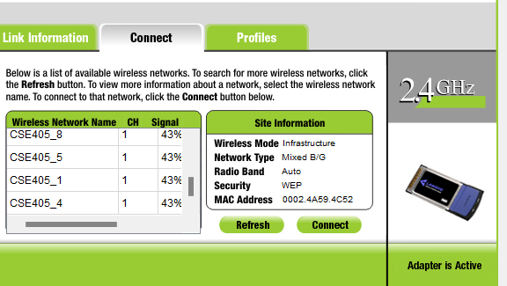

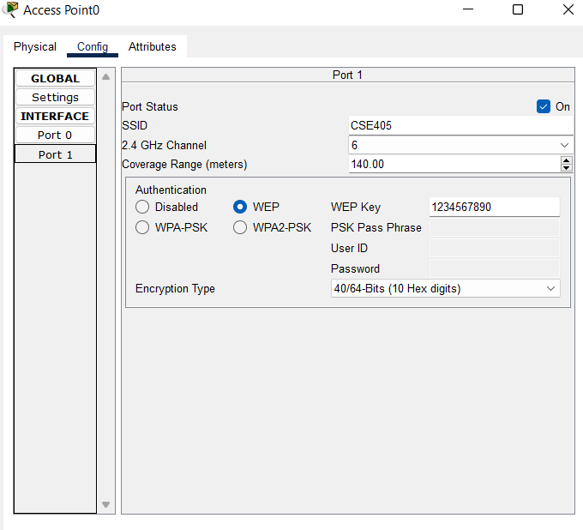

Thus, the entire network was properly connected and communications between any devices in the complex network was established.

## **Special Requirements:**

As per the special requirements for creating this network,

* The servers were kept in a separate LAN in the form of a server room.
* DHCP server was used to dynamically provide IP address to hosts belonging to all the different networks.
* Sub-Nets were incorporated in each of the Campus Networks.

# Limitations:

* In this network, there are many pc’s, laptops and routers which will be much costly to create the proper network.
* Devices should be maintained correctly else it will be a cause of error while packet transferring.
* An extra server room for servers that may need to maintain perfectly and it id costly too.

# Codes to configure the router:

|  |
| --- |
| **Interfaces:**  **Campus – 1**  enable  config t  interface fe0/0  ip address 192.168.40.254 255.255.255.0  no shut  do wr  exit  enable  config t  interface fe0/0  ip address 192.168.10.254 255.255.255.0  no shut  do wr  exit  interface se2/0  ip address 192.168.90.1 255.255.255.0  clock rate 2000000  no shut  do wr  exit  interface se3/0  ip address 192.168.120.1 255.255.255.0  clock rate 64000  no shut  do wr  exit  interface se6/0  ip address 192.168.110.1 255.255.255.0  clock rate 64000  no shut  do wr  exit  **Campus – 2**  enable  config t  interface fe0/0  ip address 192.168.60.254 255.255.255.0  no shut  do wr  exit  interface se2/0  ip address 192.168.150.1 255.255.255.0  clock rate 64000  no shut  do wr  exit  interface se3/0  ip address 192.168.110.2 255.255.255.0  clock rate 64000  no shut  do wr  exit  **Campus – 3**  enable  config t  interface fe0/0  ip address 192.168.60.254 255.255.255.0  no shut  do wr  exit  interface se2/0  ip address 192.168.190.1 255.255.255.0  clock rate 64000  no shut  do wr  exit  interface se3/0  ip address 192.168.180.1 255.255.255.0  clock rate 64000  no shut  do wr  exit  **Campus – 4**  enable  config t  interface fe0/0  ip address 192.168.50.254 255.255.255.0  no shut  do wr  exit  interface se2/0  ip address 192.168.140.1 255.255.255.0  clock rate 64000  no shut  do wr  exit  interface se3/0  ip address 192.168.100.2 255.255.255.0  clock rate 64000  no shut  do wr  exit  **Campus – 5**  enable  config t  interface fe0/0  ip address 192.168.30.254 255.255.255.0  no shut  do wr  exit  enable  config t  interface fe1/0  ip address 192.168.20.254 255.255.255.0  no shut  do wr  exit  interface se2/0  ip address 192.168.90.2 255.255.255.0  clock rate 64000  no shut  do wr  exit  interface se3/0  ip address 192.168.130.1255.255.255.0  clock rate 64000  no shut  do wr  exit  interface se6/0  ip address 192.168.100.1 255.255.255.0  clock rate 64000  no shut  do wr  exit  **Campus – 6**  enable  config t  interface fe0/0  ip address 192.168.80.254 255.255.255.0  no shut  do wr  exit  interface se2/0  ip address 192.168.160.1 255.255.255.0  clock rate 64000  no shut  do wr  exit  **Campus – 7**  enable  config t  interface fe0/0  ip address 192.168.70.254 255.255.255.0  no shut  do wr  exit  interface se2/0  ip address 192.168.120.2 255.255.255.0  clock rate 64000  no shut  do wr  exit  interface se3/0  ip address 192.168.130.2 255.255.255.0  clock rate 64000  no shut  do wr  exit  interface se6/0  ip address 192.168.150.2 255.255.255.0  clock rate 64000  no shut  do wr  exit  interface se7/0  ip address 192.168.140.2 255.255.255.0  clock rate 64000  no shut  do wr  exit  interface se8/0  ip address 192.168.160.2 255.255.255.0  clock rate 64000  no shut  do wr  exit  interface se9/0  ip address 192.168.190.1 255.255.255.0  clock rate 64000  no shut  do wr  exit  **Routing Table**  Router ospf 0  network 192.168.60.0 0.0.0.255 area 0  network 192.168.110.0 0.0.0.255 area 0  network 192.168.180.0 0.0.0.255 area 0  network 192.168.150.0 0.0.0.255 area 0  Router ospf 1  network 192.168.190.0 0.0.0.255 area 1  network 192.168.70. 0.0.0.255 area 1  network 192.168.140.0 0.0.0.255 area 1  network 192.168.160.0 0.0.0.255 area 1  network 192.168.150.0 0.0.0.255 area 1  network 192.168.130.0 0.0.0.255 area 1  network 192.168.120.0 0.0.0.255 area 1  Router ospf 2  network 192.168.100.0 0.0.0.255 area 2  network 192.168.140.0 0.0.0.255 area 2  network 192.168.50.0 0.0.0.255 area 2  Router ospf 3  network 192.168.10.0 0.0.0.255 area 3  network 192.168.120.0 0.0.0.255 area 3  network 192.168.90.0 0.0.0.255 area 3  network 192.168.110.0 0.0.0.255 area 3  network 192.168.40.0 0.0.0.255 area 3  Router ospf 4  network 192.168.90.0 0.0.0.255 area 4  network 192.168.130.0 0.0.255 area 4  network 192.168.100.0 0.0.0.255 area 4  network 192.168.20.0.0.0.255 area 4  network 192.168.30.0 0.0.0.255 area 4  Router ospf 5  network 92.168.160.0 0.0.0.255 area 5  Router ospf 6  network 192.168.170.0 0.0.0.255 area 6  network 192.168.190.0 0.0.255 area 6  network 192.168.180.0 0.0.0.255 area 6 |

# Conclusion:

It can be concluded that complex network of University of Scholars given design was performed properly. There can be some errors, in contrast, I am a simple learner. If found some error take it as my mistakes. But I tried to cover all concepts withing it. The network design incorporated in a way that all campus can conduct together their daily activities. There were many problems establishing the network. Overall, it was amazing to create this full-fledged complex network.

**Thank you!**